The Trekking Dog Trainer  & Vet Tech  www.trekkingdogtrainer.com | - 217-859-6696
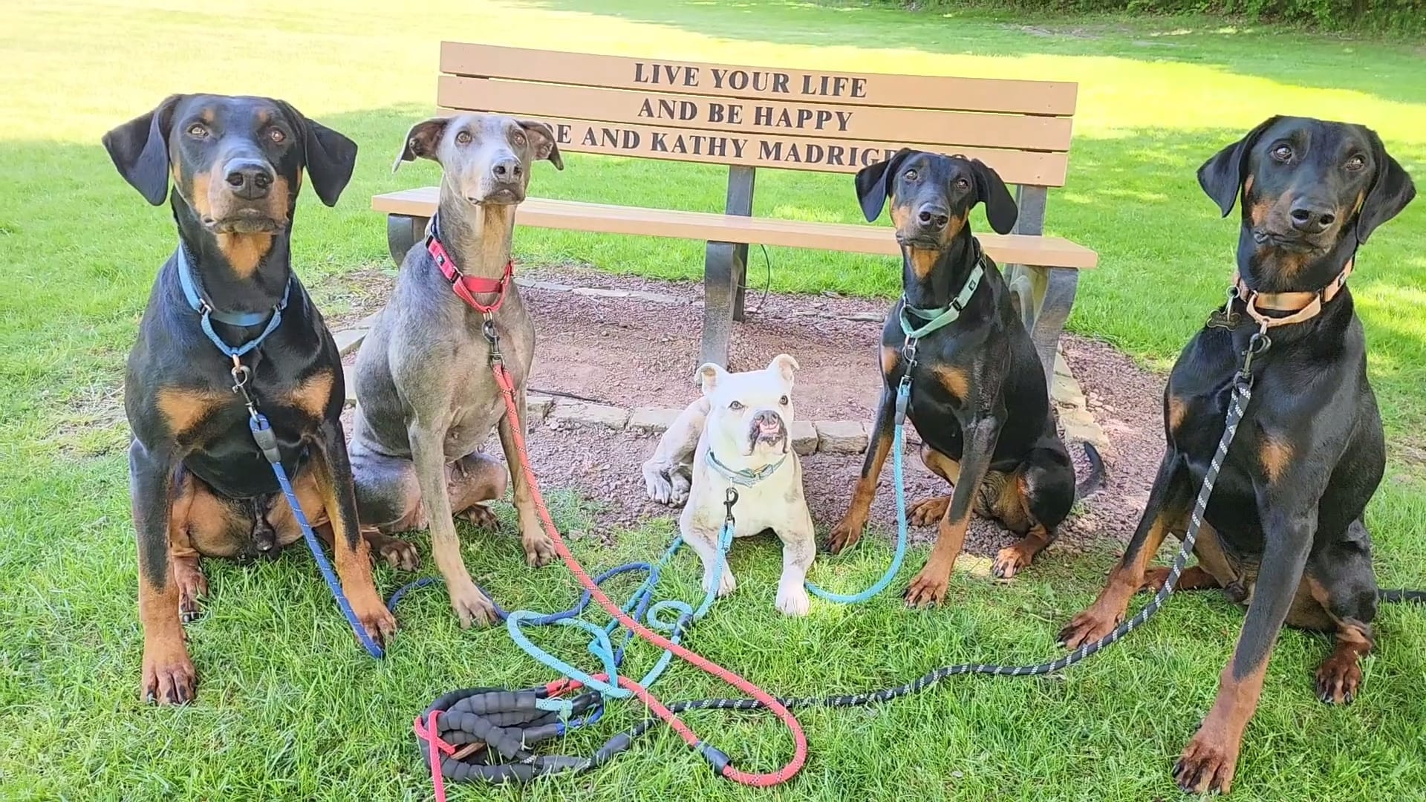  Professional Dog Training  & Behavioral Modification Services  - Personalized Training Lessons at the owner’s home or on field trips to local pet-friendly locations  - All levels of Life Skills & Manners taught in real-world settings, from Puppy through Service Dog tasking  - Aggression & Reactivity Modification  - Anxiety Relief Programs  - Day Camp & Field Trip Sessions now available  - Cooperative Care Veterinary Office and/or Groomer Sessions  - Tricks Programs  - CGC & Therapy Dog Prep  - Tracking & Nose Work  - Workshops on various topics  - Games Days  - Rescue Dog Oasis Days  - Calendar Cues online video instructional programs on many topics for Long-Distance Learning  - Healy micro-current frequency therapies (esp good for older dogs or those with anxiety)  - Snuffle Enrichment Mats also available routinely for fundraisers | 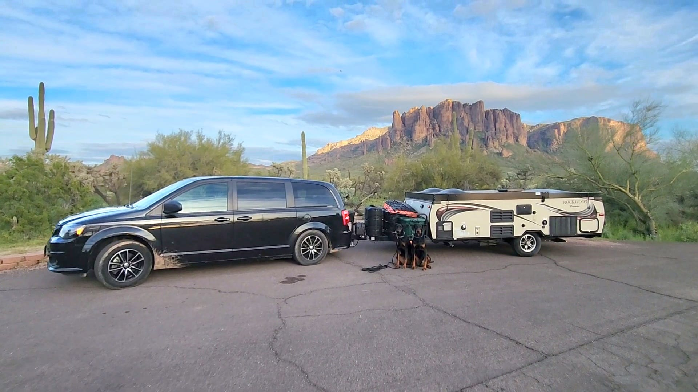  Veterinary Technician & Other Services  - Specializing in Cooperative Care & Fear Free Techniques  - Nail Timming & Dremel Drill  - Anal Gland Expression  - Ear Cleanings  - Medication Administration & Home Lessons  - Fluid Demonstrations/Adm  - 24hr Holter Monitor Rental for heart cases and OFA  - Cooperative Care Home Training Programs  - Field Trips to vet offices and groomers  - Healy micro-current frequency therapies  - Behavioral Outreach Programs (for Vet Support Staff, Shelters & Rescues)  - Aromatherapy Training Sessions  - Personalized Pet Sitting Options
We work hard to stay at the forefront of the latest humane methodologies, advanced technology and recent case studies to provide our students with the most thorough, integrative & holistic approach to behavior modification and animal care.

